MANAGEMENT OF BUILDING MATERIALS

Software Design Specification

Table of Contents
Software Design Specification 1
1: Introduction: 2
1.1 Goals and goals 2
1.2 Scope statement 2
1.3 Software context 2
1.4 Main limitations 2
2.0 Data Design 2
2.1 Internal software data structure 2
2.2 Global data structure 2
2.3 Temporary data structures 2
3.0 Component Level Design 3
3.1 Description for Homepage 3
3.1.1 Narrative Processing for Homepage 3
3.1.2 Description of the Home page interface 3
3.1.3 Homepage processing details 3
3.1.3.1 Performance issues 3
3.2.3.2 Design Constraints 4
3.3 Description for individual functions năng 4
3.3.1 Narrative processing for individual functions 4
3.3 .2 Description of individual functional interfaces. 4
3.3 .3 Personal function handling details 4
3.3 .3.1 performance issues 4
3.3 .3.2 Modular Design 5
4 The application has all 7 functions: 5
1. Sign-in and log-out functions 5
2. Registration function 6
3. Customer management function 6
4. Supplier management function 7
5. Chức năng quản lý vật liệu 7
6. Invoice creation function 8
7. Invoice list view function 9
5.0 Restrictions, limitations and constraints 9
6.0 Testing Issues 9
6.1 Types of tests 9
6.2 Expected software response 10

1: Introduction:
This document outlines the requirements for building materials management.
Construction material management application is an application for shops, traders of materials such as cement, paint, corrugated iron, iron, steel, ..
With this application, the store can easily manage materials in terms of quantity and quality.

1.1 Goals and goals
The goal of the project is to create an application that manages materials easily in terms of quantity as well as quality.

1.2 Scope statement
The only inputs to this project are user attention and strategic moves; and the only output is entertainment as a consequence of the input.

1.3 Software context
The big picture of this project will be to provide entertainment to anyone with access to the device

1.4 Main limitations
Since this project can easily be broken down into several smaller working pieces, there are few major constraints.

2.0 Data Design

2.1 Internal software data structure
The data of each product to be managed will be stored in the application. Will use the most appropriate method to store their data. All data will be stored in function specific variables or as a file on the phone memory card.

2.2 Global data structure
The system will be very modular with each game generating and storing data independent of each other and the overall system. Each function will store its own data regarding high scores, game state, preferences, etc. All this persistent data will be stored on the phone memory card as a flat file or in a separate database for each game.

2.3 Temporary data structures
Each function will also need to store temporary information like current score, user choices, etc. While this information will be temporarily stored as variables during the process, they will be saved to the phone's memory card in case the user exits mid-game.

3.0 Component Level Design
Our system is based on a home page through which individual games can be accessed. Anytime the user can exit the game, it will return them to the main menu.

3.1 Description for Homepage
The home page is the first thing a user sees when launching an app on their phone running their phone.

3.1.1 Narrative Processing for Homepage
From the home page, the user can select one of the functions or choose to exit the application. When a function is selected, the activity specific to that application is launched. If the user chooses to exit the application will be closed and the user will return to the operating system interface.

3.1.2 Description of the Home page interface
The home page will include a simple list of buttons that correspond to individual games as well as a button to choose to exit the application.

3.1.3 Homepage processing details

3.1.3.1 Performance issues
The homepage will use relatively few resources, as it will just be a list of buttons.

3.2.3.2 Design Constraints
The homepage should be simple and easy to use to access individual games.

3.3 Description for individual functions năng
The individual functional components will be launched from the home page and will run independently of each other .

3.3.1 Narrative processing for individual functions
When each game is launched, the user is given a choice such as choosing words from the word search or choosing a column to place a chip for connect four. The user of this option will result in increased happiness points or a chip placed in the function board for example. This process of the user making selections and the results processed will continue until the game is completed, successfully or otherwise, or the user chooses to quit or restart the game. Users will also have the option to restart the game, which will result in the process starting from scratch.

3.3 .2 Description of individual functional interfaces.
Each game will have on-screen buttons that the user can press to use the function. In the case of connecting functions, users will be able to press one of the buttons at the top of the board to select the column to place their chips in. There will also be a home button for each function, which will give more options like exit or restart.

3.3 .3 Personal function handling details

3.3 .3.1 performance issues
Each function responds quickly to user input via on-screen buttons. Delayed response can lead users to frustration or believe that the application is frozen.

3.3 .3.2 Modular Design
The design of the interface for the game should be simple and intuitive so that users can easily determine what options they have available to develop the application.

4 The application has all 7 functions:
The application has all 7 functions:

1. Sign-in and log-out functions
To be able to manage building materials, you must first log in to the system by entering your email and password.
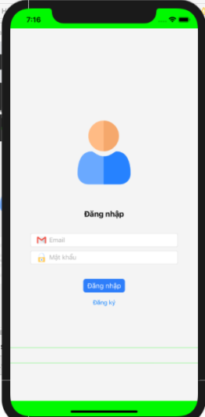

Figure 1: login function interface
Once logged in successfully, it will lead to the main interface of the application, when you want to log out, just click the logout button, it will return to the login function.
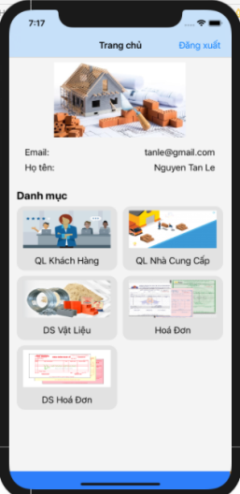
Figure 2. Main interface of building materials management application.

Home page
Category:
customer management
Supplier management
Material List
Invoices
List of invoices

2. Registration function
When you want to manage materials but do not have an account, you need to register by entering your email, password, full name and address.
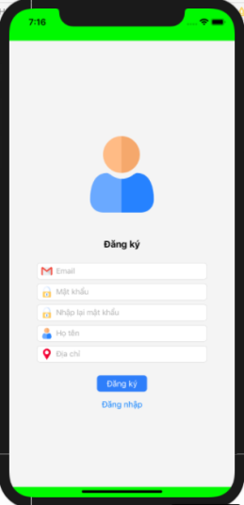

Figure 3. Registration function interface
- Enter email
- Enter password
- Enter the password
- Enter your first and last name
- Enter address

3. Customer management function
At the customer management function, we can add customers by entering information and pressing the add button, customer information will be saved into the system.

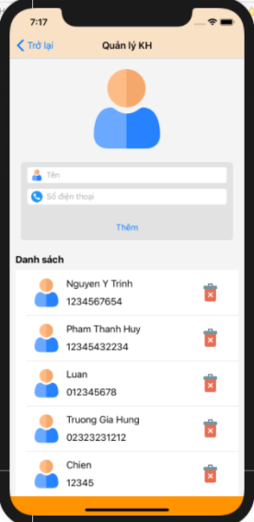

Figure 4: Customer management function interface
- Enter name
- Enter your phone number
- Delete button

4. Supplier management function

To add a supplier, it is necessary to fill in the information and then press the add button, the supplier will be saved in the system.
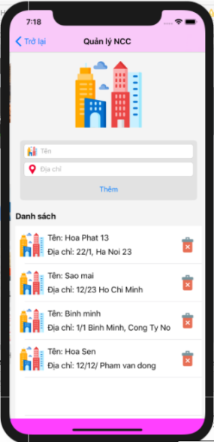

Figure 5: Vendor management function interface
- Chức năng quản lý vật liệu

When clicking on the material management function, the test will display a list of materials already in the system.

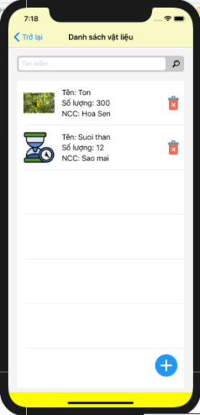

Figure 6: Material list interface
Enter the name of the material you want to search
When you want to add materials, users just need to click on the plus sign, then fill in the information and press the add button, the material will be added to the system.
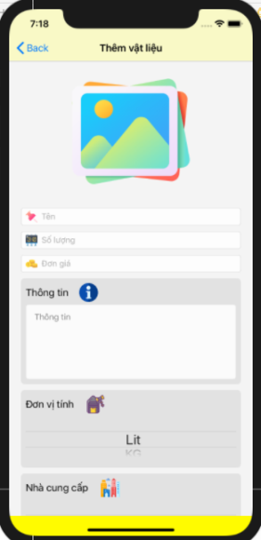

Figure 7: Material add function interface
- Enter name
- Enter data
- enter unit price
- Enter information
- Unit

6. Invoice creation function
When a customer comes to buy, after entering the customer's information, the user needs to create an invoice.
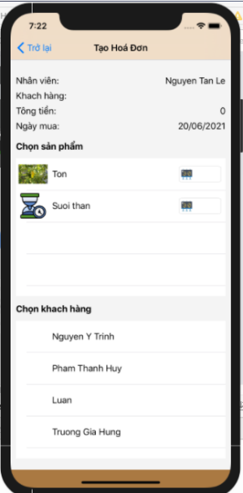

Figure 8: Invoice creation function interface.

7. Invoice list view function
After creating invoices, users need to review the invoice editing schedule, then click on the invoice DS item to review the created invoices.

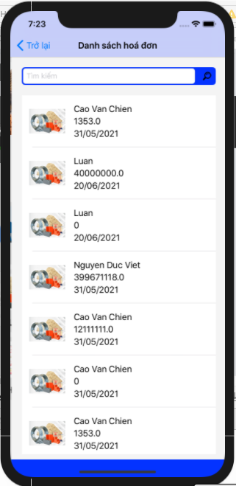

Figure 9: Invoice list view function

5.0 Restrictions, limitations and constraints
Let the Suite management app be downloaded and installed to . All development for the Game Suite is done in the Eclipse Integrated Development Environment (IDE) on Windows XP and Vista machines with the Software Development Kit (SDK).

6.0 Testing Issues

6.1 Types of tests
We will conduct the first tests on individual functionality in the Suite as separate entities using the IOS Simulator provided by the IOS Software Development Kit (SDK). After each individual game is thoroughly tested, the package is built together and tested as a whole. All known valid input will be checked as well as known invalid input. A more comprehensive overview of our testing strategies will be included in our test specification document.

6.2 Expected software response
Each test performed will be clearly observed as failure or success.

